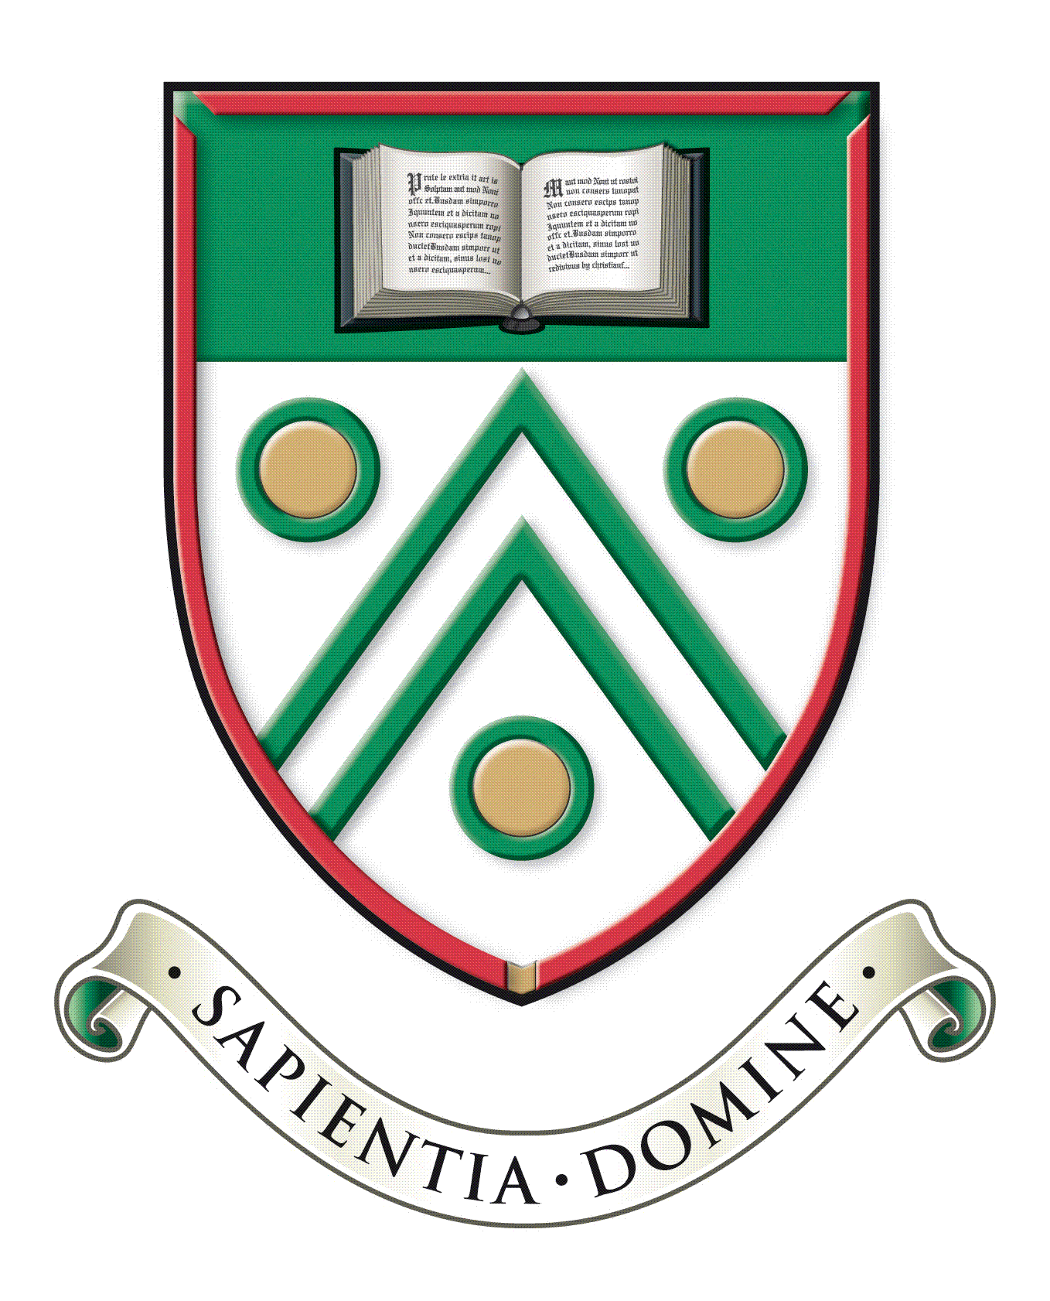

Langley Grammar School
Reddington Drive
Langley, Berkshire. SL3 7QS

Tel: 01753 598300
e-mail: school@lgs.slough.sch.uk
web: www.lgs.slough.sch.uk
Headteacher: Mr J Constable

Teacher of Mathematics
Main scale (London Fringe)
Full time or substantial part time (0.6 FTE or above)
Required for September 2022

We are offering an exciting opportunity for an enthusiastic and well-qualified Teacher of Mathematics to join a highly successful Mathematics department in our outstanding selective school. Langley Grammar school has an excellent record for student outcomes in mathematics and the subject is very popular subject among our students.

The successful applicant will teach Mathematics in all key stages; a significant number of students study Mathematics in the Sixth Form and a strong academic background and ability to teach Mathematics to A-level is therefore essential. The potential to teach A-Level Further Mathematics will also be an advantage. We will consider applications for full time or substantial part time (at least 0.6 FTE); applications from both suitability qualified NQTs and more experienced teachers are welcome.

Langley Grammar School is a co-educational 11-18 selective school with academy status, located within easy reach of Langley station and the M4. We have approximately 1240 students, over 330 of whom are in the Sixth Form. The school is heavily over-subscribed and draws students from a wide geographical area and range of backgrounds. Alongside promoting excellent academic outcomes, our school ethos supports students to become confident and well rounded, independent and creative, responsible and caring. Our students are capable, hardworking and a delight to teach. We are a National Teaching School with a record of nationally recognised innovative practice, and an Apple Distinguished School in recognition of our leading-edge use of technology for learning. In recent years major building programmes have included the construction of excellent sports facilities, a distinctive Sixth Form Centre and new classrooms, workshops, laboratories, ICT suites and communal areas. Our most recent Ofsted report dates from an inspection in 2007. The school was graded outstanding in all categories.

Information packs and application forms are available on request from the school, or can be downloaded from the school website at www.lgs.slough.sch.uk.

We are committed to safeguarding and promoting the welfare of children and expect all staff to share this commitment. Applicants must be willing to undergo child protection screening appropriate to the post, including checks with past employers and the Disclosure and Barring Service.

Applications should be returned by midday on Friday 4 February 2022 to Mrs Dionne Cheyne, Head’s PA at vacancies@lgs.slough.sch.uk. Interviews will be held thereafter. We reserve the right to interview promising candidates prior to the closing date.

