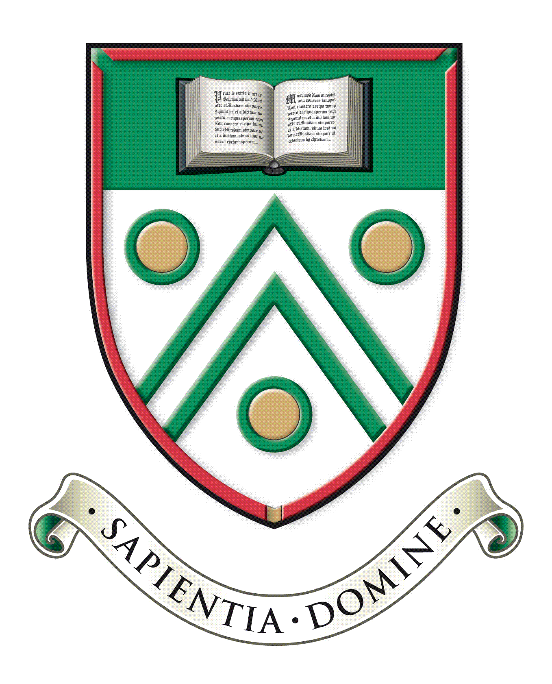

Langley Grammar School
Reddington Drive
Langley, Berkshire. SL3 7QS

Tel: 01753 598300
e-mail: school@lgs.slough.sch.uk
web: www.lgs.slough.sch.uk
Headteacher: Mr J Constable

Teacher of Business Studies
Main Scale London Fringe,
Full time or substantial part time (minimum 0.6FTE)

Required for September 2022

Langley Grammar School has an outstanding record for student performance. We are seeking a well-qualified and enthusiastic teacher of Business Studies to work full time, or part-time (minimum 0.6FTE).

The successful candidate would be expected to teach Business Studies to GCSE. We also offer the subject in the Sixth Form, so the successful candidate will need to well qualified and be confident in teaching A Level to our academically able students. The ability to teach a second subject in the humanities would be advantageous, particularly Economics. The post would suit an excellent classroom practitioner at any stage of their career, and applications from NQTs are welcome.

Langley Grammar School is a co-educational 11-18 selective school with academy status, located within easy reach of Langley station and the M4. We have approximately 1240 students, over 330 of whom are in the Sixth Form. The school is heavily over-subscribed and draws students from a wide geographical area and range of backgrounds. Alongside promoting excellent academic outcomes, our school ethos supports students to become confident and well rounded, independent and creative, responsible and caring. Our students are capable, hardworking and a delight to teach. We are a National Teaching School with a record of nationally recognised innovative practice, and an Apple Distinguished School in recognition of our leading-edge use of technology for learning. In recent years major building programmes have included the construction of excellent sports facilities, a distinctive Sixth Form Centre and new classrooms and laboratories. The Science department benefits from brand new facilities and is housed in our new teaching block, which opened in 2020. Our most recent Ofsted report dates from an inspection in 2007. The school was graded outstanding in all categories.

Information packs and application forms are available on request from the school, or can be downloaded from the school website at www.lgs.slough.sch.uk.

We are committed to safeguarding and promoting the welfare of children and expect all staff to share this commitment. Applicants must be willing to undergo child protection screening appropriate to the post, including checks with past employers and the Disclosure and Barring Service.

Applications should be returned by midday on Monday 31 January addressed to Mrs Dionne Cheyne, Headteacher’s PA at vacancies@lgs.slough.sch.uk. Interviews will take place as soon as possible after the closing date although we reserve the right to interview promising candidates prior to this date if applications are received early.

