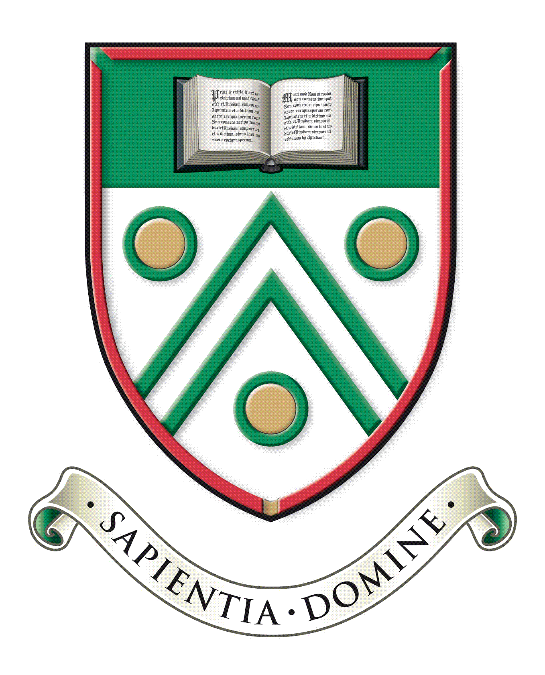

Langley Grammar School
Autumn 2020 Examination series

A - Level Entry Request

Student name
Candidate number
Contact phone number

For full details of the Autumn examination series, please refer to the websites of the individual examination boards.
Please indicate below the subject(s) you wish to be entered for.
Subject | Exam board | Level (AS or A Level)

Student signature
Date

Please return this form to the Examinations Officer, Mrs Muckley, as soon as possible and no later than 12.00 noon on Monday 24th August.
The form can be handed in to the school Reception, or sent via email to michellemuckley@lgs.slough.sch.uk

