Health and Wellbeing

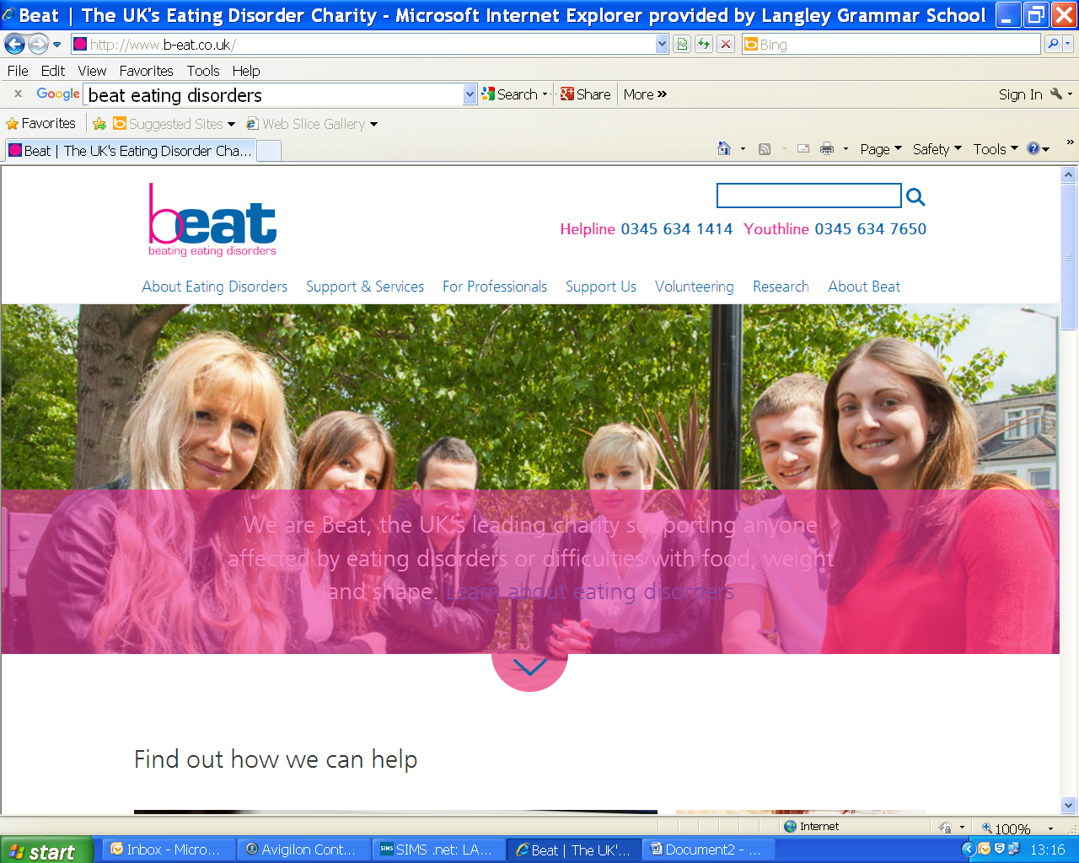

Helplines, online support and a network of UK-wide self-help groups to help beat eating disorders.

http://www.b-eat.co.uk/

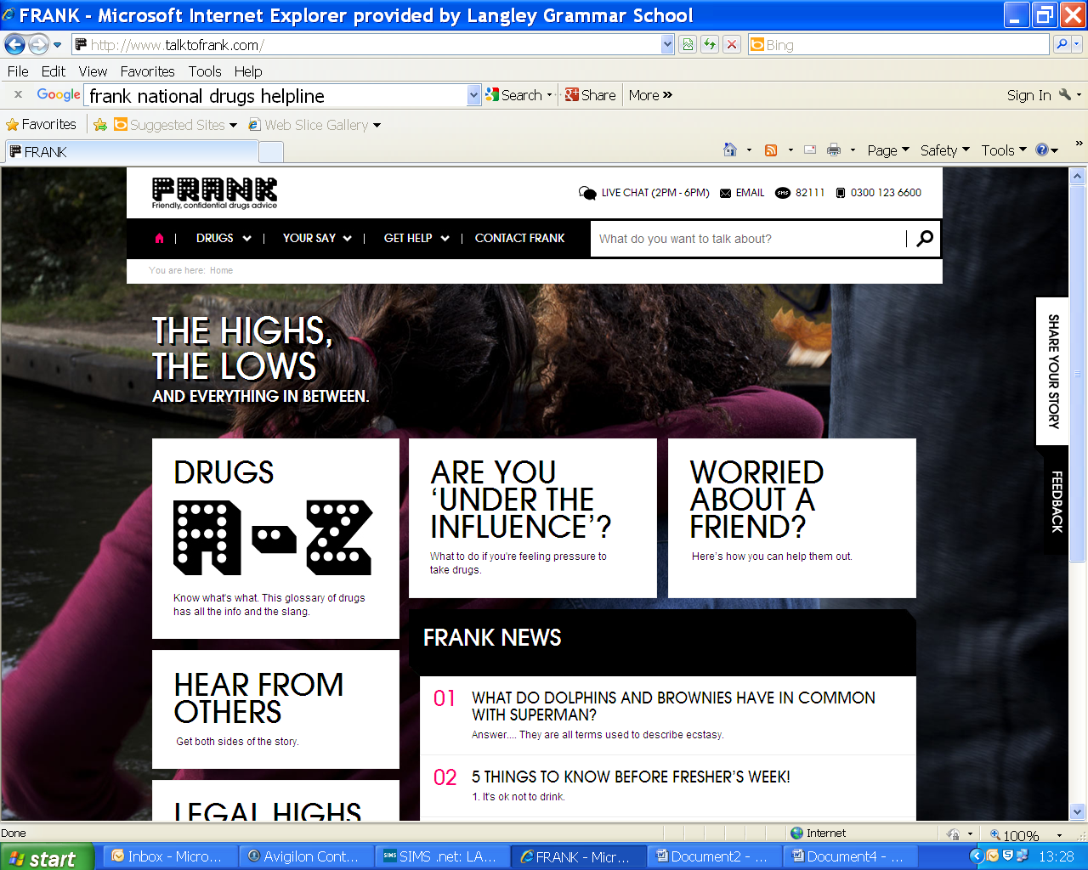

National drug education service providing targeted and accurate information on drugs and alcohol.

http://www.talktofrank.com/

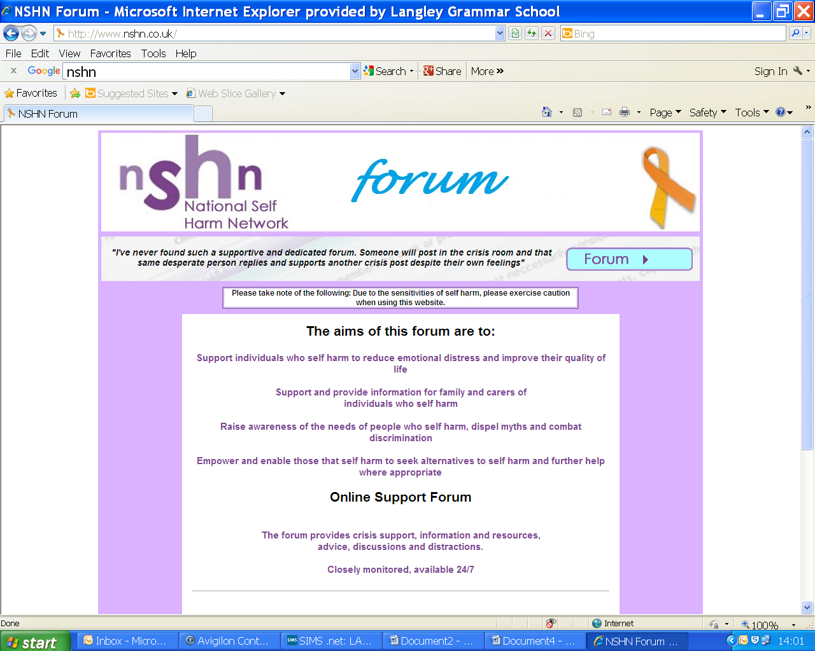

The lead UK charity offering support, advice and advocacy services to people affected by self harm.

http://www.nshn.co.uk/

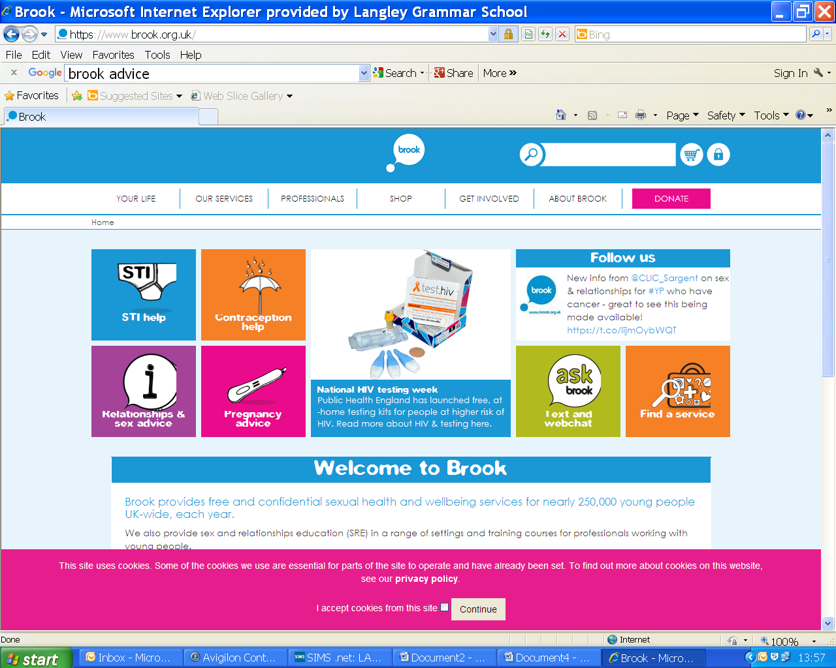

Advice and information on contraception, STI’s, sex, relationships and pregnancy.

https://www.brook.org.uk/

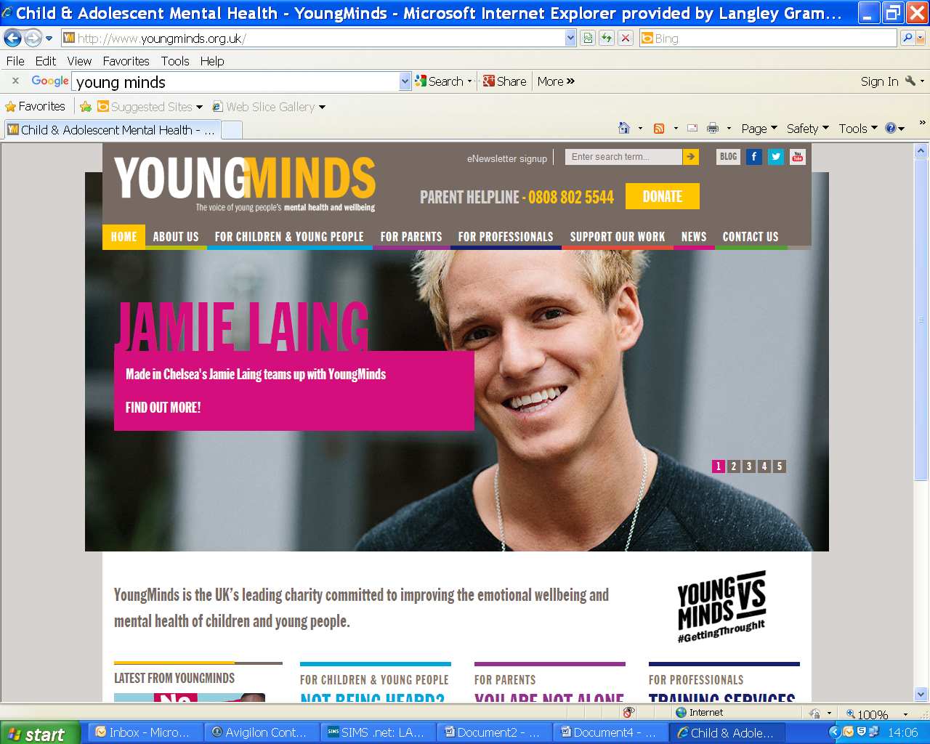

Young Minds is the UK’s only national charity committed to improving the mental health and emotional well-being of all children and young people.

http://www.youngminds.org.uk/

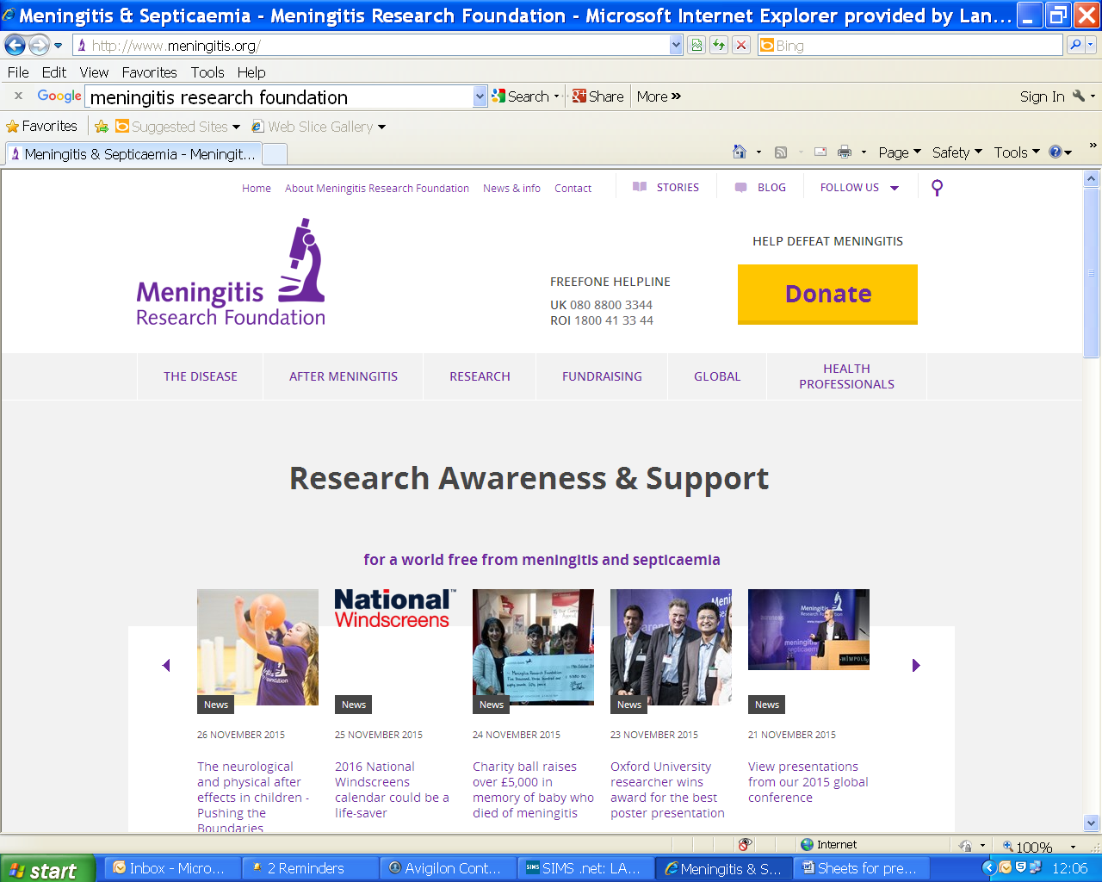

Funds research to prevent meningitis and septicaemia, improve survival rates and outcomes.

http://www.meningitis.org/

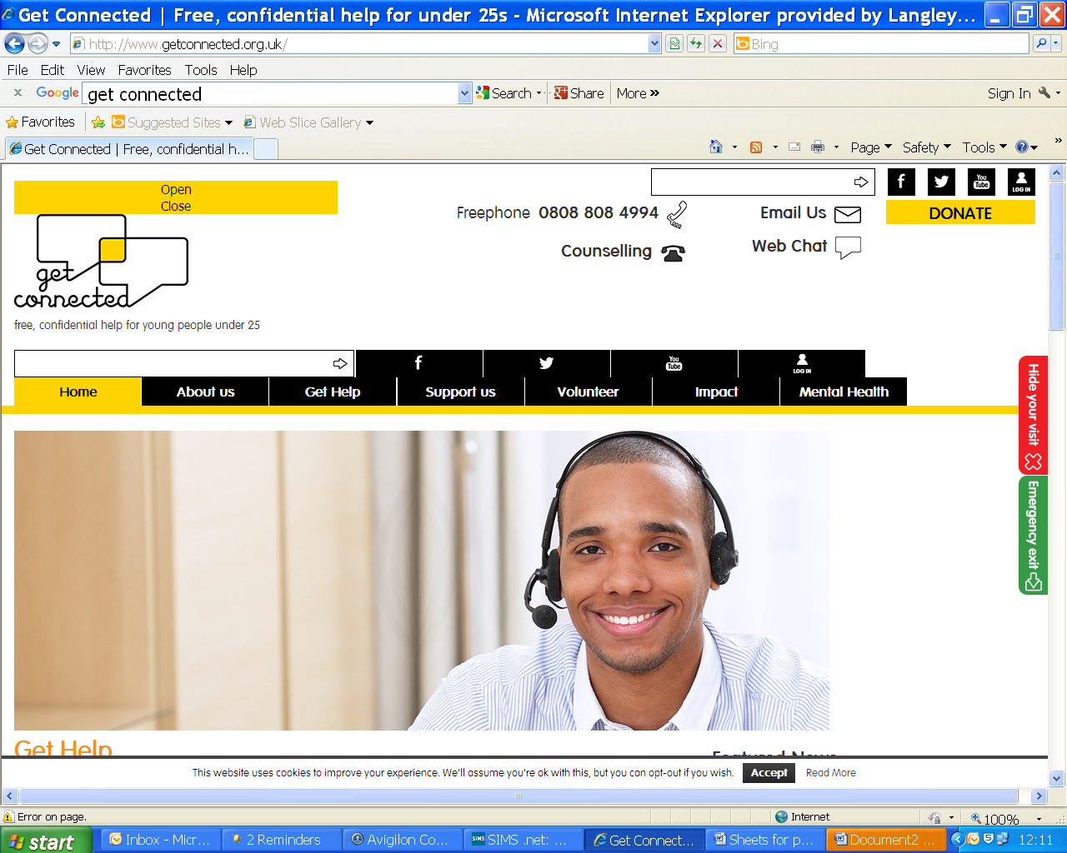

The national helpline for young people under 25. Provides free confidential help.

http://www.getconnected.org.uk/

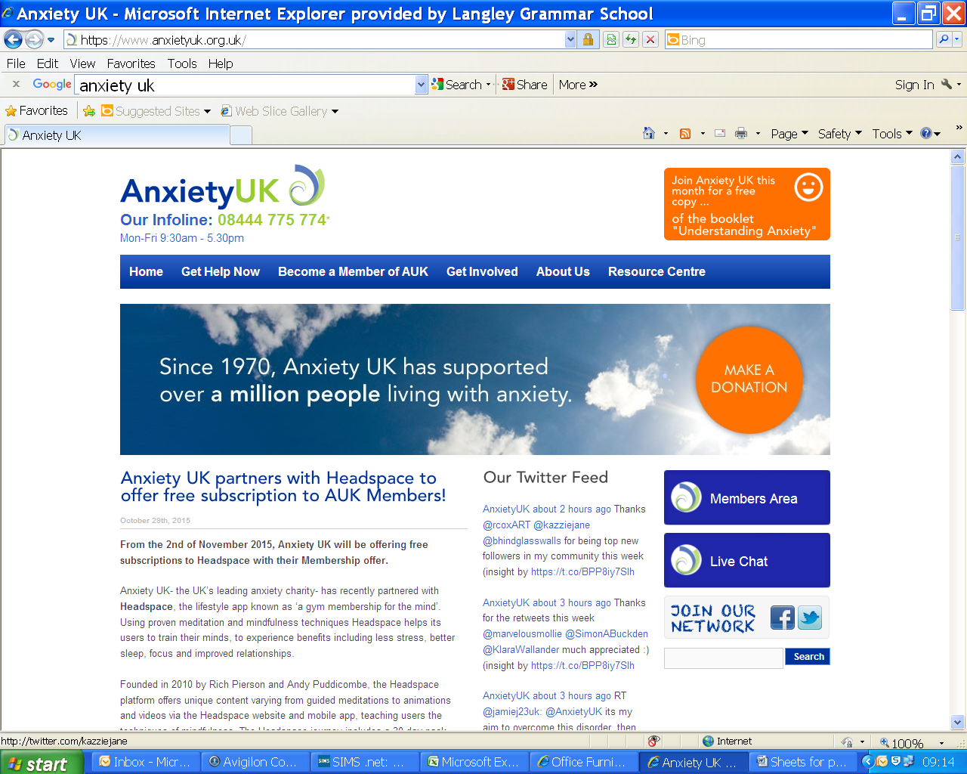

Works to relieve and support those living with anxiety disorders by providing information, support and understanding.

https://www.anxietyuk.org.uk/

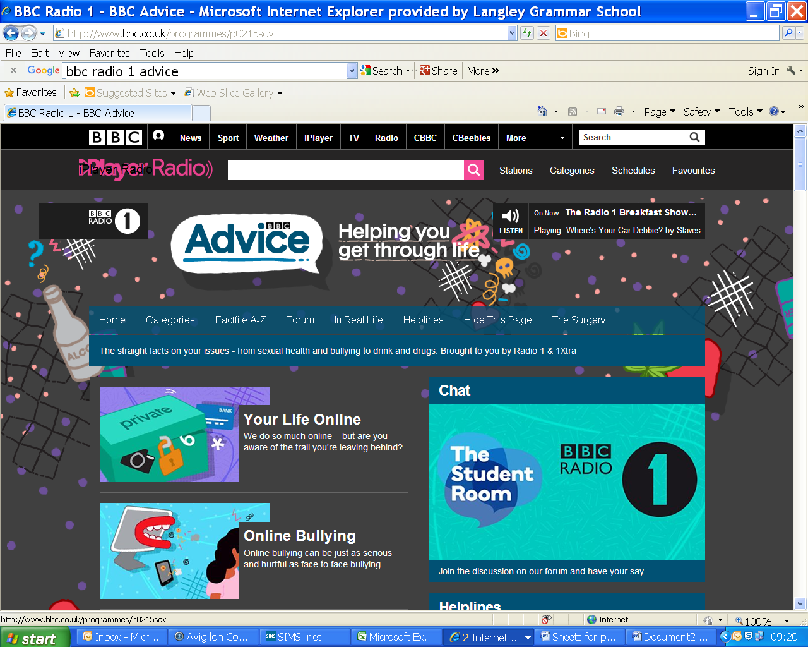

Advice, helplines and websites from e-safety to dealing with anxiety and stress.

<http://www.bbc.co.uk/>

programmes/p0215sqv

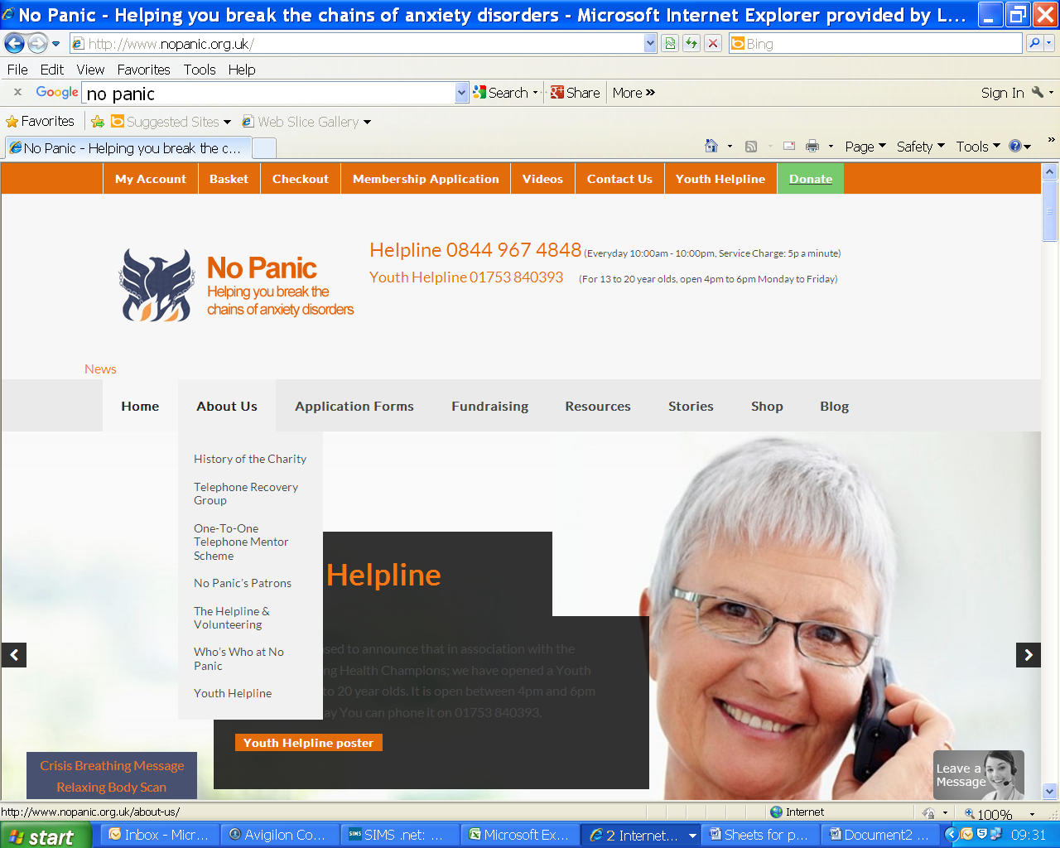

Offers information, advice and a youth helpline to help deal with anxiety and panic attacks.

http://www.nopanic.org.uk/

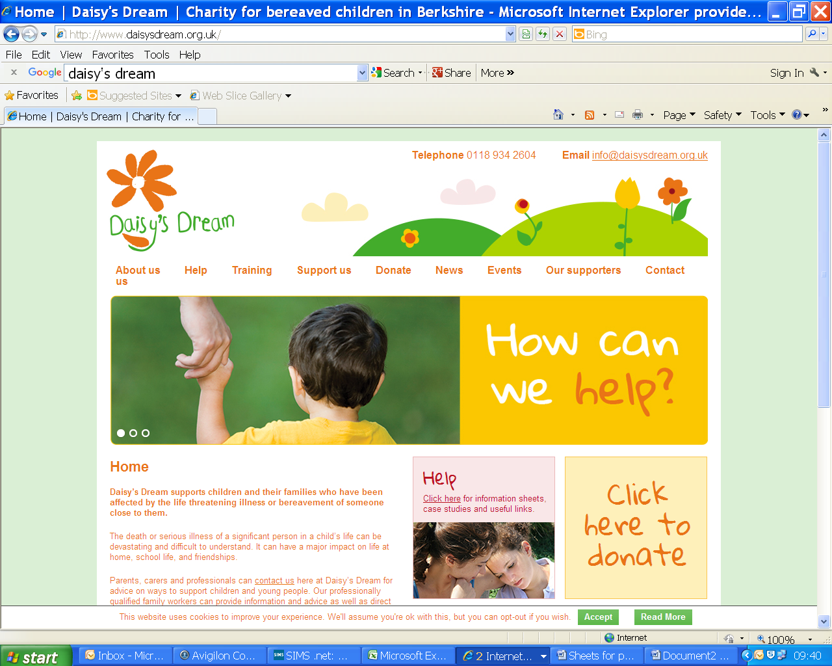

Berkshire charity for children and young people who have been affected by bereavement.

http://www.daisysdream.org.uk/

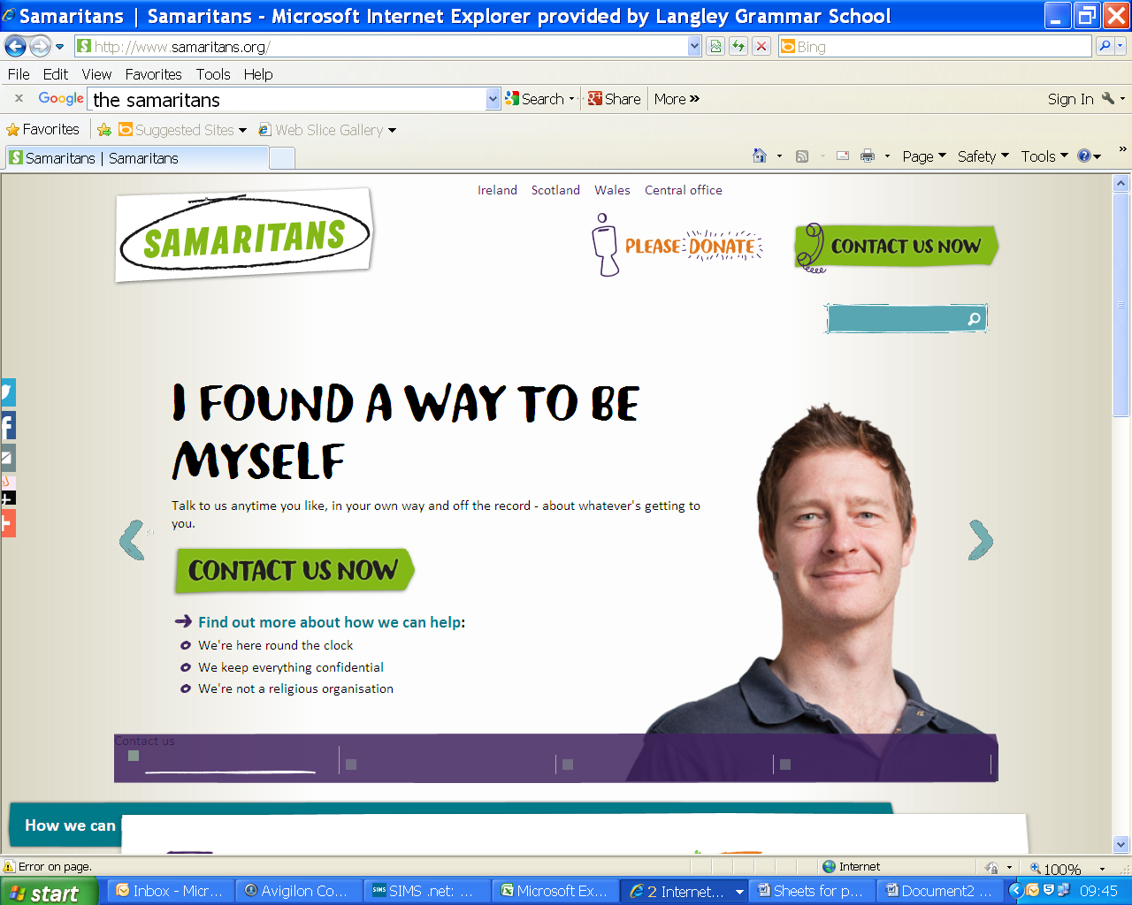

Offers a 24 hour service for people who need to talk about whatever is getting to them.

http://www.samaritans.org/

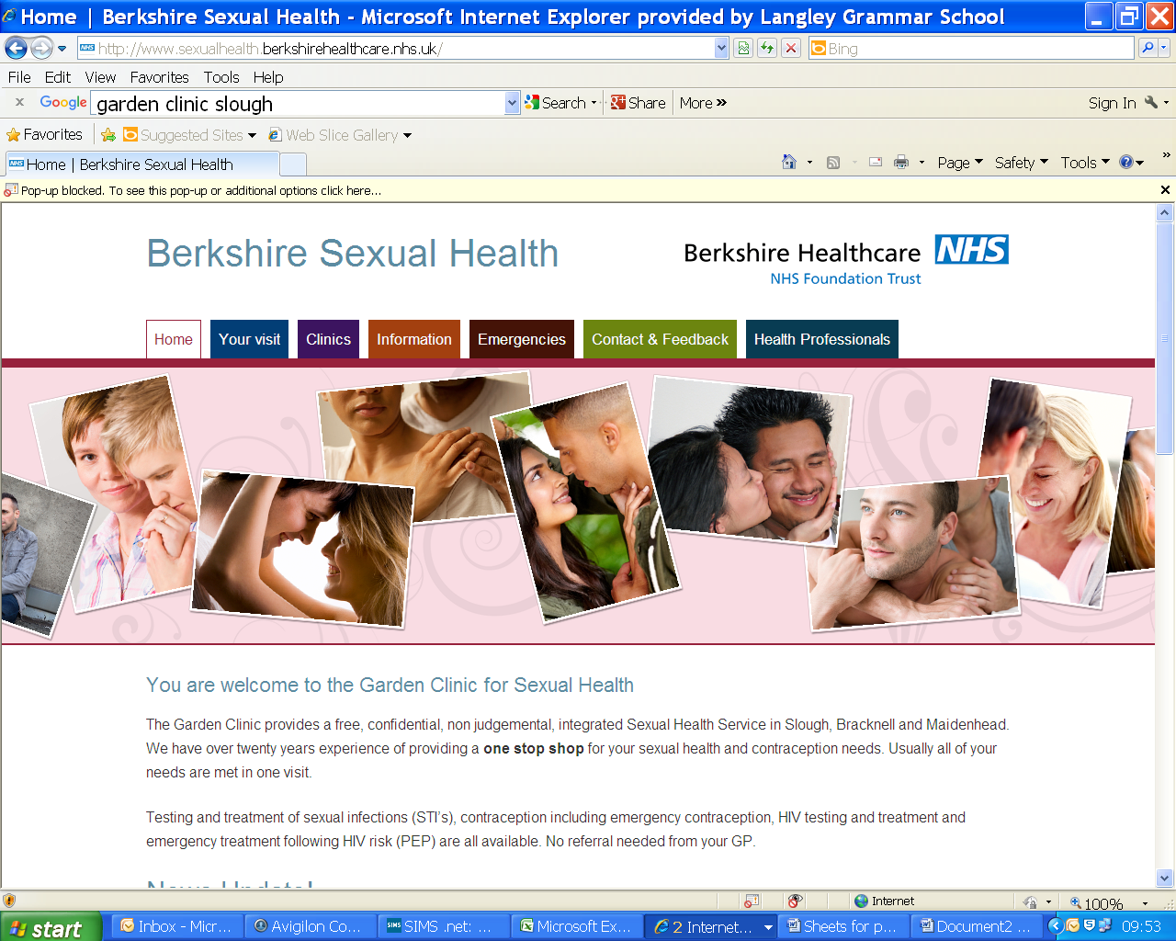

Offers a free confidential, non-judgemental sexual health service in Slough, Maidenhead and Bracknell.

http://www.sexualhealth.berkshirehealthcare.nhs.uk/

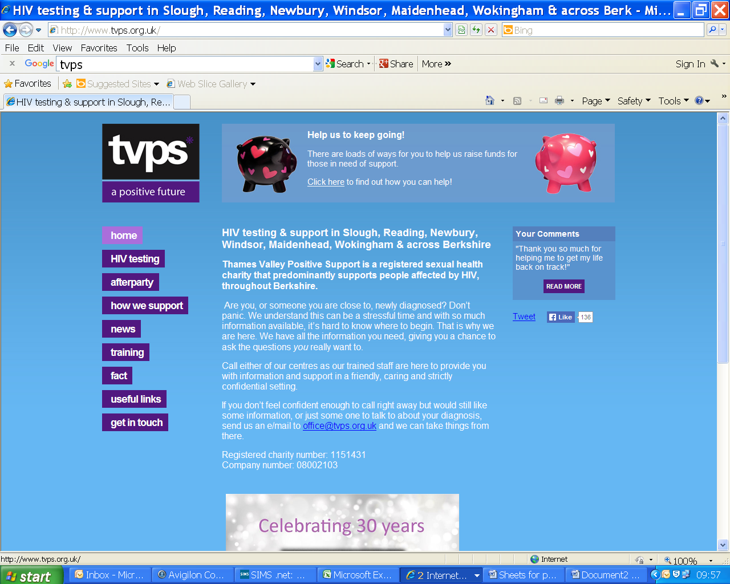

HIV testing and support across Slough and Berkshire.

http://www.tvps.org.uk/

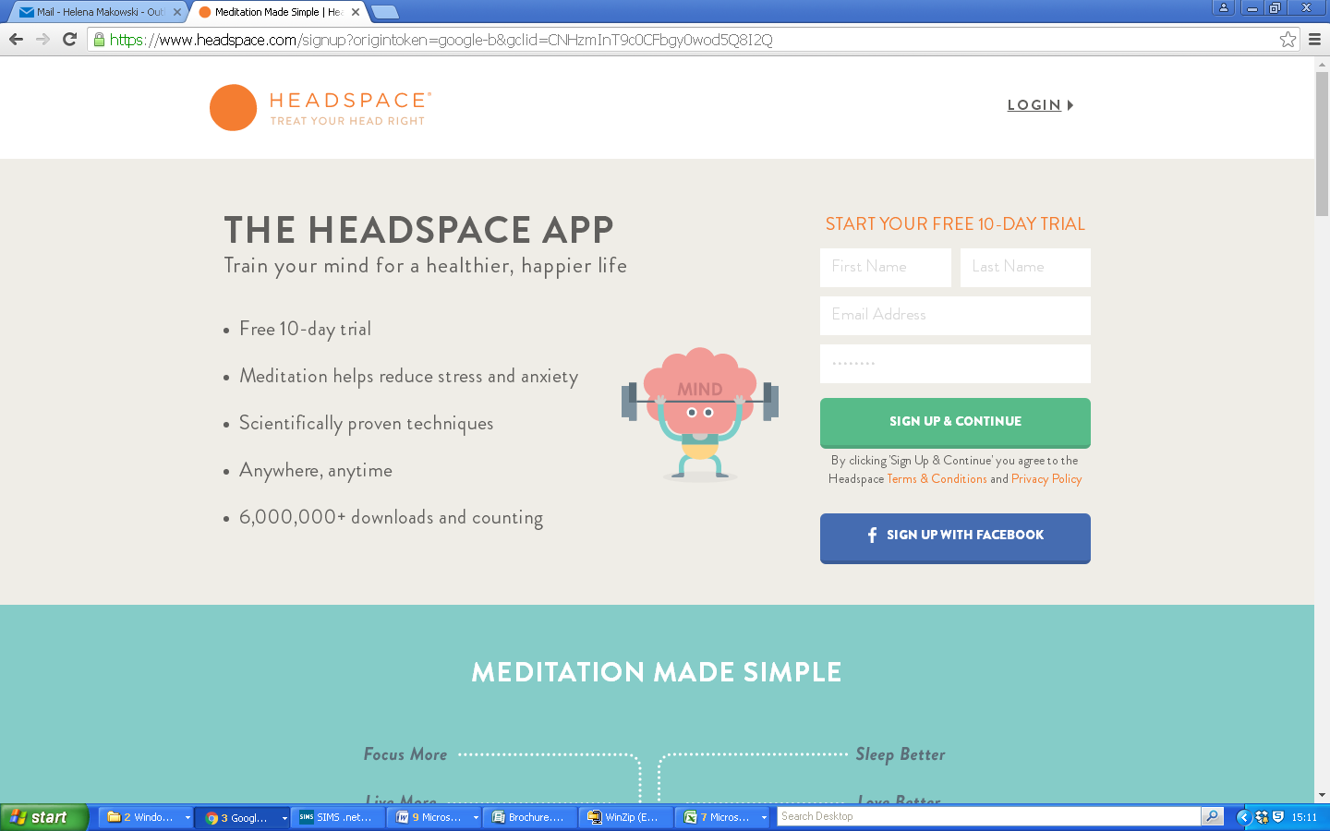

www.headspace.com



www.livingwell.org.au/mindfulness